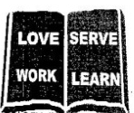


THE REAL SCHOOLS
LEARNER’S EMPOWERMENT ACTIVITIES
P.6 TERM I 2025 INTEGRATED SCIENCE
CIRCULATORY SYSTEM

Victoria P/S

Golden Junior
School

Makindye Junior School

An excellent first grade and excellent character for every pupil

NAME………………………………………………………………………CLASS: …………………………
SCHOOL: ……………………………………………………………………………………………………….
THEME: THE HUMAN BODY
TOPIC: CIRCULATORY SYSTEM
Learner’s outcomes: To enable the learner;
- Appreciates the importance of blood in the body.
- Develops further understanding of how blood circulates in the body.
Background knowledge: Body organs
Relevancy and functionality: The learner can:
- Give the function of heat.
- State the process of blood flow.
Key learning principles:
- Circulatory system: Is the system that transports blood to circulate through the body.
Lerner centred approach.
Tasks a learner to put the right arm on the left side of the chest.
SESSION ONE
Competences:
- Describes the circulatory system.
- Understands the structure of human heart.
- Understands the functions of the human heart.
- Understands the process of blood circulatory.
CONTENT
Circulatory system
Is the transporting system of the body that circulates blood through the body.
Blood circulation
Is the movement of blood around the body.
Types of blood circulation.
Pulmonary circulation: Transports deoxygenated blood to the body.
Systematic circulation: It sends oxygenated blood out to cells.
Parts of circulatory system.
●The heart ●Blood ●Blood vessels
The human heart
- It is a muscular organ
- It pumps blood around the body.
- It is protected by the ribcage.
Conditions which may change the heart beat.
*Physical exercise *State of excolment
The structure of the human heart.
- It is made of cardiac muscles.
- It is divided into four chambers ie
- The upper chambers-atria ie left atrium and right atrium
- The lower chambers – left ventricle and right ventricles.
- The heart has values to prevent back flow of blood.
Diagram of the human heart.

Functions of the labelled parts.
Ven cava (main vein): It carries deoxygenated blood from all parts of the body to the heart.
Pulmonary artery: It carries deoxygenated blood from the heart to the lungs.
Pulmonary vein: It carries oxygenated blood from the lungs to the heart.
Process of blood circulation in the body
Circulation of blood is supported by four main vessels.
Vena cava, pulmonary artery, pulmonary vein, aorta.
The heart receives blood from all parts of the body through the vena cava when blood reaches the right atrium is pumped to the lungs through the pulmonary artery.
Kinds of blood carried by the heart.
▪oxygenated blood ▪deoxygenated blood
Mini activity
1. Name the body organ that pumps blood to all parts of the body.
____________________________________________________________________________
2. Define blood circulation.
____________________________________________________________________________
3. Apart from the left atrium, give the other chambers of the heart.
____________________________________________________________________________
4. Give the body organ that is made up of cardiac muscles.
____________________________________________________________________________
5. State the function of the septum muscle in the heart.
____________________________________________________________________________
MEGA ACTIVITY
1. Write down any two parts of the circulatory system.
i) ____________________________________ ii) ____________________________________
2. State the practice that may change the human heart beat.
____________________________________________________________________________
3. Of what importance are the valves to the human heart?
____________________________________________________________________________
4. Name the human body organ that is made up of cardiac muscles.
____________________________________________________________________________
5. Give the reason why blood is first pumped to the lungs before its transported to all parts of the body.
____________________________________________________________________________
6. Mention the instrument used to listen to the human heart beats.
____________________________________________________________________________
7. State the function of the aorta.
____________________________________________________________________________
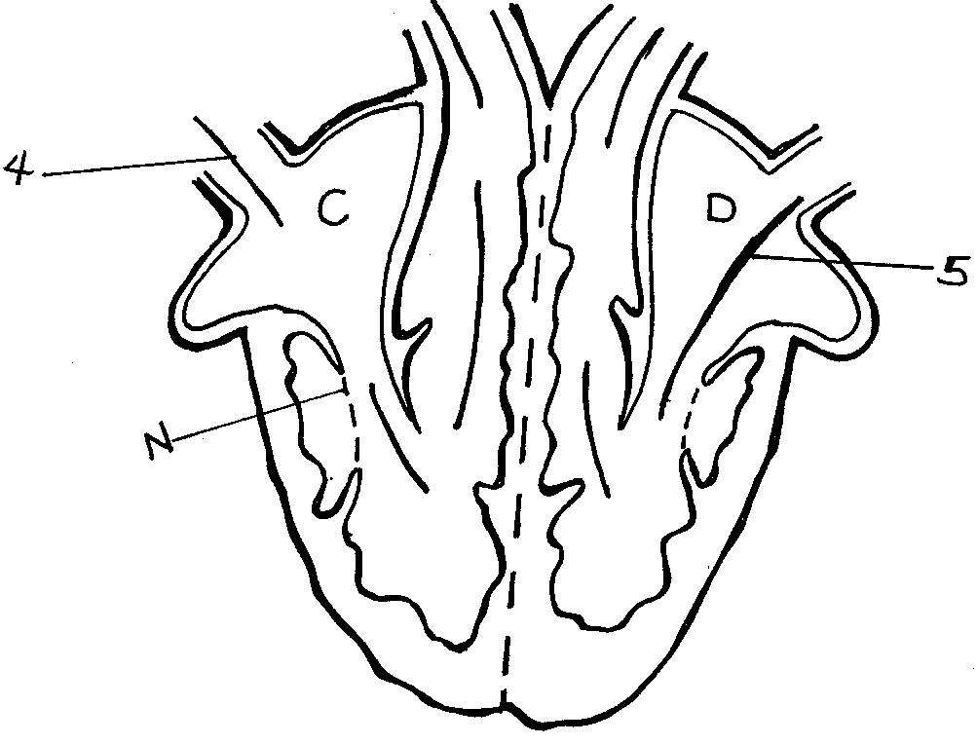
The diagram below shows the human heart. Study and use it to answer questions 8 and 9.

8. Label parts marked
i) K __________________________________ ii) A _________________________________
iii) M ________________________________ iv) N _________________________________
9. How useful I the septum muscles in the heart?
___________________________________________________________________________
10. Why is the right side of the heart thin walled?
____________________________________________________________________________
11. Give the reason why the heart of a person running pumps blood too fast?
____________________________________________________________________________
12. Which part of the human body protects the heart?
____________________________________________________________________________
project work
Use the local materials like boxes to make a cut out of the human heart.

SESSION TWO
THEME: THE HUMAN BODY
TOPIC: CIRCULATORY SYSTEM
Background knowledge: Body organs
Relevancy and functionality: The learner can:
- State the difference between the component of blood.
- Give the function of blood.
Competences:
- Understands blood.
- Understands the components of blood.
- Understands each component of blood.
Lerner centred approach.
Give the learners a mixture of red ink and water.
CONTENT
BLOOD
Blood is a red liquid that is transported continuously through blood vessels in the body.
Components of blood.
Plasma Platelets

Red blood cells White blood cells

Red blood cells
  - Red blood cells transport oxygen to all parts of the body.
  - They are made in the red bone marrow of short and flat bones e.g ribs and contain a red pigment called hemoglobin
Hemoglobin carries oxygen in blood.
Characteristics of red blood cells
- They are thin in size.
- They don’t have a nucleus.
Adaptation of red blood cells.
- They are many in number which enables them to transport more oxygen.
- They do not have nucleus which increases space for carrying more oxygen
Structure of a red blood cell.
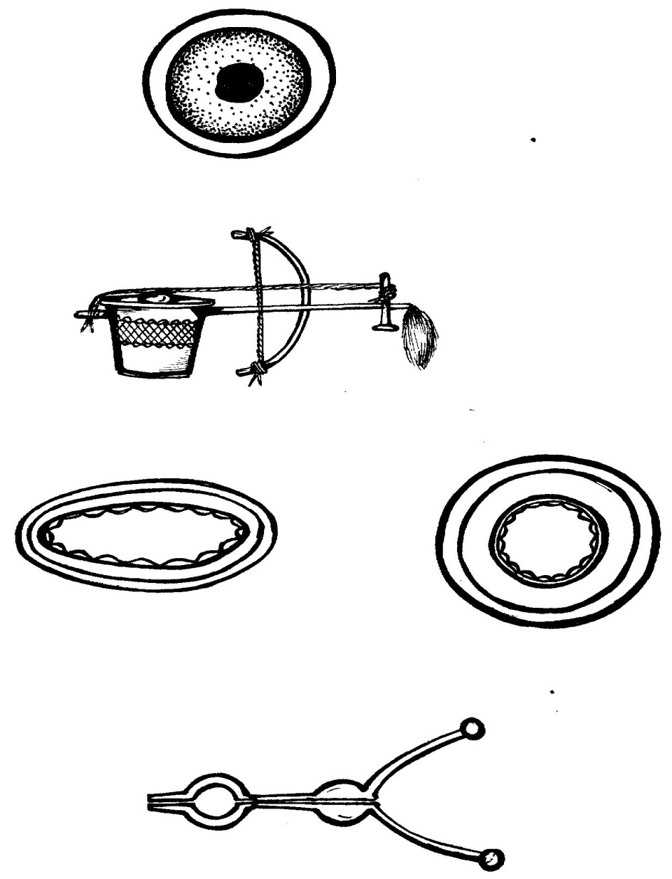

White blood cells
- They protect the body against diseases/infection.
- They are made from bone marrows of long bones, spleen.
- They have irregular shape to enable then engulf the germs.
Characteristics of white blood cells.
- They have a nucleus.
- They don’t have a definite shape.
Structure of white blood cells.
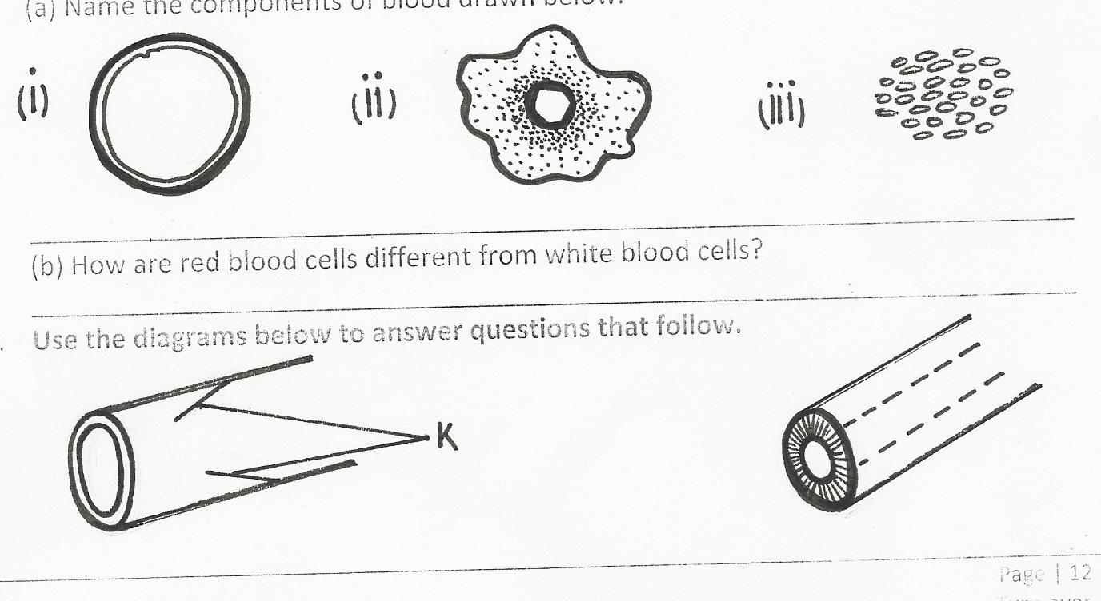
nucleus

Adaptations of white blood cells to their functions.
Have irregular shape for engulfing germs.
Ways ow white blood cells defend the body against diseases.
- By engulfing and digesting germs.
- By producing antibodies against germs.
- By producing antigens against germs.
Blood platelets (thrombocytes)
- They help in blood clotting.
- They are made in the red bone marrow.
Functions of the blood platelets.
- Platelets help in blood clotting.
- Platelets prevent germ invasion through open wounds.
Structure of blood platelets.

Blood plasma
It carries cells and proteins throughout the body.
It is yellowish in colour.
Components of blood plasma.

Digested food Glucose Amino acids

Importance of blood plasma.
- Transports carbon dioxide from all parts of the body ie lungs.
- Transports digested food to all parts of the body.
Blood transfusion
- Is the transfer of tested and screened blood form one person to another.
- A person with blood group AB is a universal recipient.
- A person with blood group O is a universal donor.
Mini activity
1. Give any one example of flat bone where red blood cells are made.
___________________________________________________________________________
2. State the function of haemoglobin in blood.
___________________________________________________________________________
3. Mention any two components of blood apart from red blood cells.
i) ____________________________________ ii) _________________________-_________
4. Draw the structure of a red blood cell.

5. State how white blood cells are able to carry their function.
__________________________________________________________________________
MEGA ACTIVITY
1. Name any one example of a bone where red blood cells are made.
___________________________________________________________________________
2. How is a blood donor different from a blood recipient?
___________________________________________________________________________
3, Why is it important to screen blood before it is transferred to another person?
___________________________________________________________________________
4. State nay one way how the red blood cells are adapted to their function.
___________________________________________________________________________
5. Mention any one waste product transferred by blood in the body.
___________________________________________________________________________
6. Why are we advised to eat food rich in iron?
___________________________________________________________________________
7. How are white blood cells able to protect the body against diseases?
___________________________________________________________________________
8. State the component of blood that help in blood clotting.
___________________________________________________________________________
9. Of what importance is the hemoglobin in the blood?
___________________________________________________________________________
Use the diagrams below showing the types of blood and use it to answer questions 10 to 12.
A
B

10. Name the types of blood cell.
i) A ____________________________________ ii) B _____________________________
11. How is blood cell A different from blood vessel B?
___________________________________________________________________________
12. Give nay one characteristic of blood cell A.
___________________________________________________________________________
SESSION THREE
THEME: THE HUMAN BODY
TOPIC: CIRCULATORY SYSTEM
Background knowledge: Diseases that affect the body organs
Relevancy and functionality: The learner can:
- Draw the structure of different blood vessels.
- Give the functions and differences between the blood vessels.
Key learning principles
Arteries: Are vessels that carry blood away from the heart.
Veins: Are vessels that carry blood to the heart
Competences:
- Understands blood vessels.
- Understands arteries.
- Understands veins.
- Understands blood capillaries.
Learner centred approach
Give the learner to draw the structure of different blood vessels
CONTENT
Blood vessels
These are muscular tubes that help in proper circulation of blood in the human body.
Types of blood vessels

Arteries Veins Capillaries

Arteries
  - These are blood vessels that carry blood away from the body.
  - Most arteries carry oxygenated blood apart form pulmonary artery.
  - They have thick walls to enable them withstand the pressure of blood pumped from the heart.
Characteristics of arteries.
They have thick walls.
They have a narrow lumen.
The structure of an artery.
Thick walls
narrow lumen

Veins
- These are blood vessels that carry blood to the heart.
- All veins carry deoxygenated blood except for the pulmonary vein.
Characteristics of veins
Veins have valves.
Veins have a wider lumen.
Structure of the veins.
valves
Thin walls

wider lumen
Differences between arteries and veins.
a) Functional difference.
Arteries | Veins
Most arteries oxygenated | Most veins carry deoxygenated blood
b) Structural differences.
Arteries | Veins
They have no valves  They have thick walls | They have valves  They have thin walls.

capillaries
- These are the smallest blood vessels that help to connect the arteries to the veins.
- They allow exchange of blood materials in the body.
Diagram showing blood capillaries.
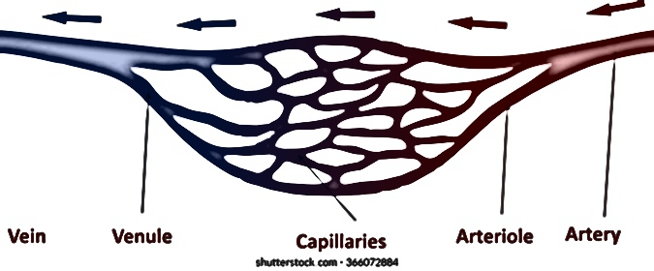

A table showing blood vessels supplying blood to different body organs.
Organ | Artery | Vein
Lungs  Kidney  Liver | Pulmonary artery  Renal artery  Hepatic artery | Pulmonary vein  Renal vein  Hepatic vein
Mini activity
1. State any two types of blood vessels.
i) ____________________________________ ii) __________________________________
2. Name the blood vessel shown below.

3. Give any two characteristics of blood vessel shown in 2 above.
i) _________________________________________________________________________
ii) _________________________________________________________________________
4. State how the blood vessel shown above is able to withstand the pressure of blood pumped.
___________________________________________________________________________
5. Give the blood vessel that carry deoxygenated blood.
___________________________________________________________________________
MEGA ACTIVITY
1. Apart from capillaries, mention any one type of blood vessel.
___________________________________________________________________________
2. How are blood capillaries important in the body?
___________________________________________________________________________
3. Give the reason why arteries have thick muscles.
___________________________________________________________________________
4. Name the structures in veins that enable blood to flow in one direction.
___________________________________________________________________________
5. How is the vena cava important in blood circulation?
___________________________________________________________________________
Study the diagrams below and use them to answer questions that follow.
x

6. Name blood vessels marked A and B.
i) A _______________________________ii) B ____________________________________
7. Label structures marked X.
___________________________________________________________________________
8. How are structures marked X important in blood vessel B?
___________________________________________________________________________
9. State one structural difference between blood vessel A and B.
___________________________________________________________________________
___________________________________________________________________________
10. Mention one functional difference between blood vessel A and B.
___________________________________________________________________________
___________________________________________________________________________
11. How are veins adapted to their function?
___________________________________________________________________________
12. Why does blood in veins flow at a low pressure?
___________________________________________________________________________
THEME: THE HUMAN BODY
TOPIC: CIRCULATORY SYSTEM
Background knowledge: Body organs (Diseases that affect the heart)
Relevancy and functionality: The learner can:
- Give the ways of preventing HIV/AIDS
- State the ways of helping a person with HIV/AIDs
- Give the ways of caring for the heart.
Key learning principles
HIV: Human Immune Deficiency Virus.
Diseases of the circulatory system and disorders.
Competences:
- Understand the disease of the circulatory system.
- Understands HIV/AIDS.
- Understands ways through which HIV and AIDS is spread.
- Understands effects of HIV/AIDS to different persons.
- Understands ways of controlling HIV/AIDS.
- Understands ways of caring for the circulatory system.
Learner centred approach
Give the examples of diseases that affect the blood and heart.

CONTENT
Diseases of the circulatory system.
*Malaria: It is caused by plasmodia spread through anopheles mosquito.
it affects the red blood cells.
*Leukemia/blood cancer.
*Anaemia e.t.c
Diseases that attack the heart.
  - Cardiac arrest/hear attack.
  - High blood pressure/hypertension
  - Coronary thrombosis.
HIV/AIDS
HIV: Human Immunodeficiency Virus.
AIDS: Acquired Immune Deficiency Syndrome.
HIV affects the white blood cells.
Signs and symptoms of AIDS
Signs Symptoms
>Chronic diarrhea >Persistent fever
>Loss of body weight >Loss of appetite.
Effects of HIV/AIDS
An individual
  - AIDS causes death to the victim.
  - It leads to loss of body immunity.
Family
  - Children become orphans when parents die
  - Loss of family income.
Community
  - It leads to loss of killed people in the community.
  - It leads to shortage of productive population.
Ways of controlling the spread of HIV/AIDS
  - Through practicing PIASCY messages.
  - Abstain from sex until marriage.
  - Avoid sharing skin piercing objects with an infected person.
Care for the organs of the circulatory system.
- Feeding on a balanced diet.
- Doing regular physical exercises.
- Avoid smoking and alcoholism.
Ways of increasing volume of blood in circulation.
  - Feeding on a balanced diet.
  - Drinking enough fluids.
  - Eating food rich in iron.
Organs related to the circulation of blood.
●The heart ●The lungs ●The small intestines.
●The kidneys ●The liver
Mini activity
1. Name the type of blood that is affected by malaria.
___________________________________________________________________________
2. Write the following in full.
a) AIDS ___________________________________________________________________
b) HIV ____________________________________________________________________
3. Name the disease that has similar related signs and symptoms as HIV/AIDS.
___________________________________________________________________________
4. State any two ways through which HIV/AIDS is spread.
i) _________________________________________________________________________
ii) _________________________________________________________________________
5. How does plasmodium germ affect the circulatory system?
___________________________________________________________________________
MEGA ACTIVITY
1. Mention any two examples of sharp piercing objects.
i) _________________________________ ii) _____________________________________
2. Why should doctors sterilize medical instruments before reusing them?
___________________________________________________________________________
3. Why are adolescent girls at a high risk of getting HIV/AIDS than boys of the same age group?
___________________________________________________________________________
4. Write down ay two examples of PIASCY messages.
i) _________________________________________________________________________
ii) _________________________________________________________________________
5. Which type of blood cell does the HIV virus affect?
___________________________________________________________________________
6. How does lack of iron in the body affect human health?
___________________________________________________________________________
7. How does HIV/AIDS affect the following:
a) Individual.
___________________________________________________________________________
b) Family
___________________________________________________________________________
c) Community
___________________________________________________________________________
8. Give any two ways a p.6 pupil can prevent him/herself from HIV/AIDS.
i) _________________________________________________________________________
ii) _________________________________________________________________________
9. State any one cultural practice that may lead to HIV/AIDS
___________________________________________________________________________
10. How are mosquito bites dangers to human health?
___________________________________________________________________________
11. Mention any one diseases that attack the heart.
___________________________________________________________________________
12. Give any one way how HIV/AIDS cannot be spread.
__________________________________________________________________________

